Dashboard Design

Date | 27 October 2026
Team ID | Not provided by user
Project Name | Global Olympic Sports Performance Analysis
Maximum Marks | 5 Marks

Creating an effective dashboard involves thoughtful design to ensure that the presented information is clear, relevant, and easily understandable for the intended audience. Here are some key principles and best practices for dashboard design
Activity 1: Interactive and visually appealing dashboards
Creating interactive and visually appealing dashboards involves a combination of thoughtful design, effective use of visual elements, and the incorporation of interactive features. Here are some tips to help you design dashboards that are both visually appealing and engaging for users so take care of below points
- Clear and Intuitive Layout
- Use Appropriate Visualizations
- Colour and Theming
- Interactive Filters and Slicers
- Drill-Down Capabilities
- Responsive Design
- Custom Visuals and Icons
- Use of Infographics

Note: Highlight the major outcomes in form of bullet points

Project Dashboard Design: Global Olympic Sports Performance Analysis
Design choice: a light, consistent dashboard style with a teal accent, descriptive titles, adequate whitespace and coordinated views. The supplied walkthrough contains visual evidence for both dashboard layouts.

Dashboard 1 - Olympic Performance
• Contains three views: average medals by category, global country performance by total medals/rank, and the trend of total medals awarded over Olympic years.
• Intended use: quickly compare countries and categories, then inspect changes over time.
• Interaction: the workbook contains a country Overall Rank range filter. Check the filter behavior in Tableau before publishing.
• Interpretation caution: total medals are affected by event counts, participation and dataset scope; ranking is descriptive.
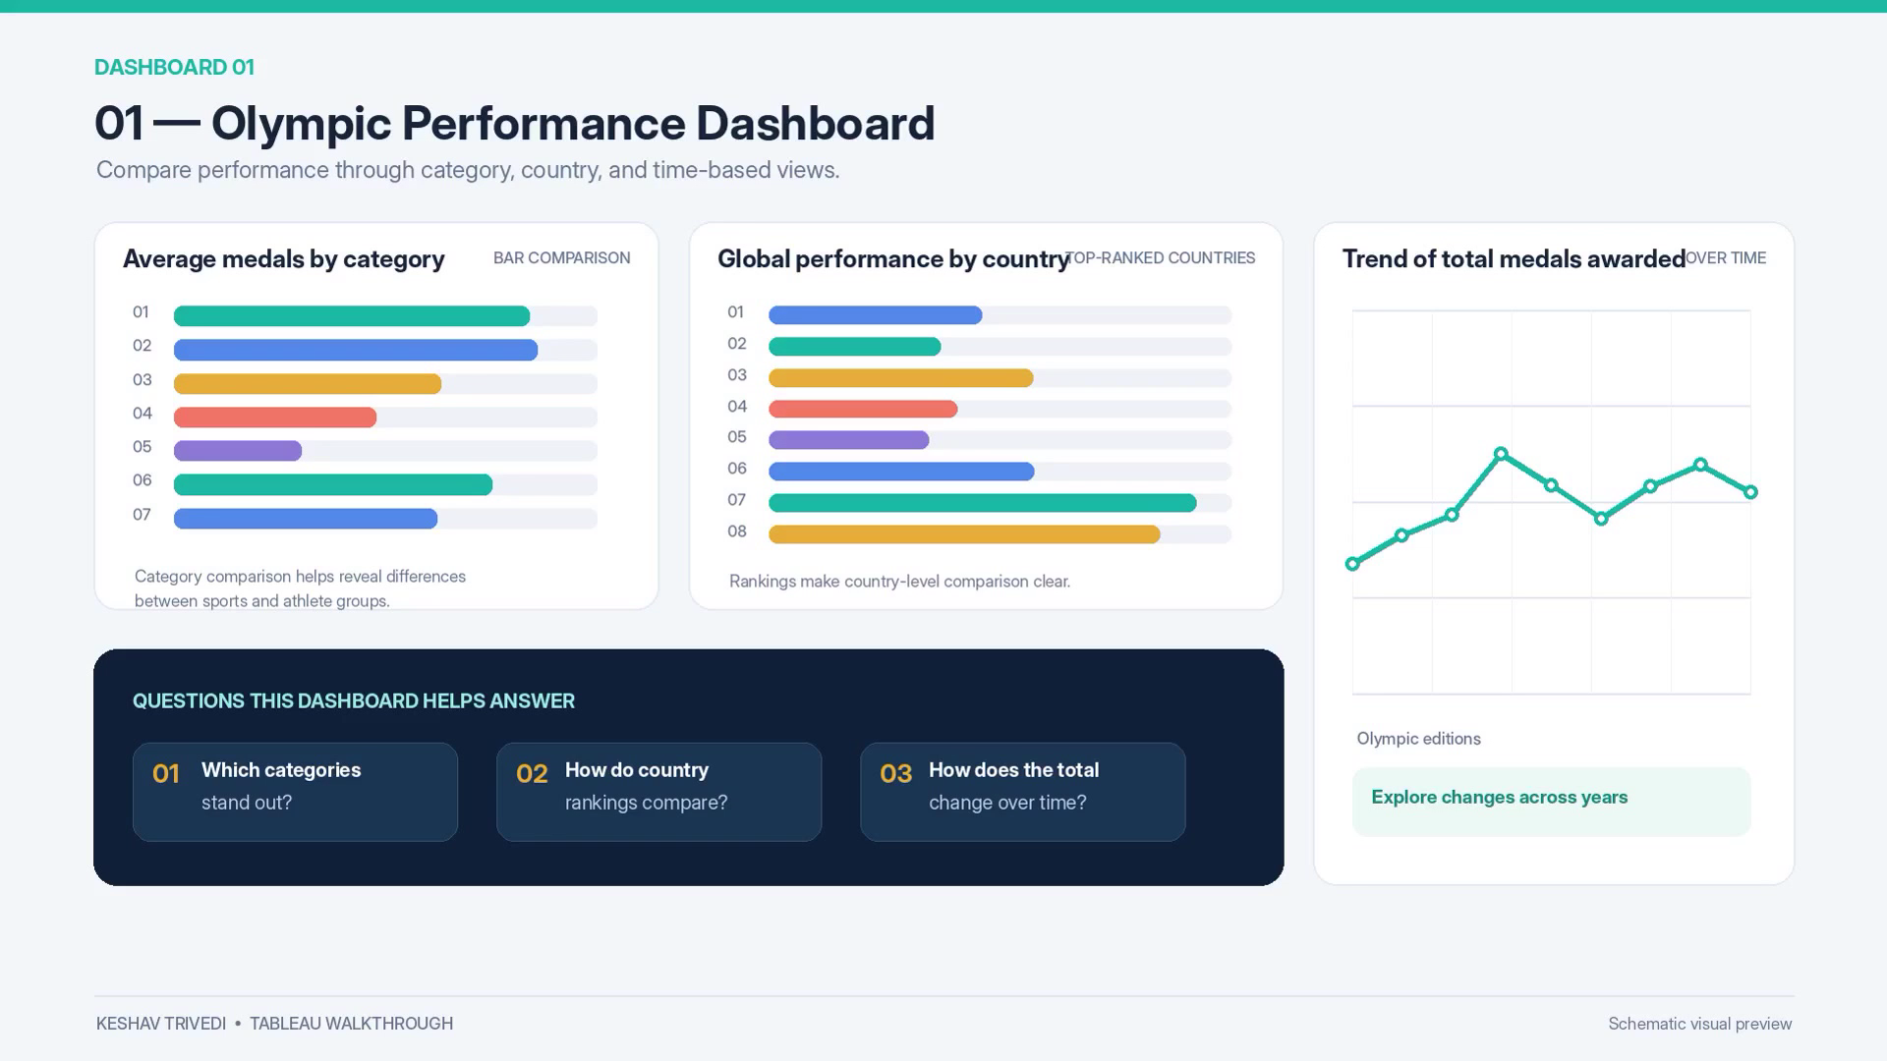
Figure 1. Olympic Performance Dashboard visual from the project walkthrough.

Dashboard 2 - Regional Efficiency
• Contains four views: investment versus medal performance, average medal efficiency by region, medals across Olympic hosts, and regional medal distribution.
• Intended use: compare regional patterns and explore contextual relationships without implying cause and effect.
• Interaction: the workbook contains a categorical Host Advantage filter. Validate which sheets it affects before publication.
• Quality checks: verify regional labels, definition/units of efficiency and the time coverage before reporting numeric findings.
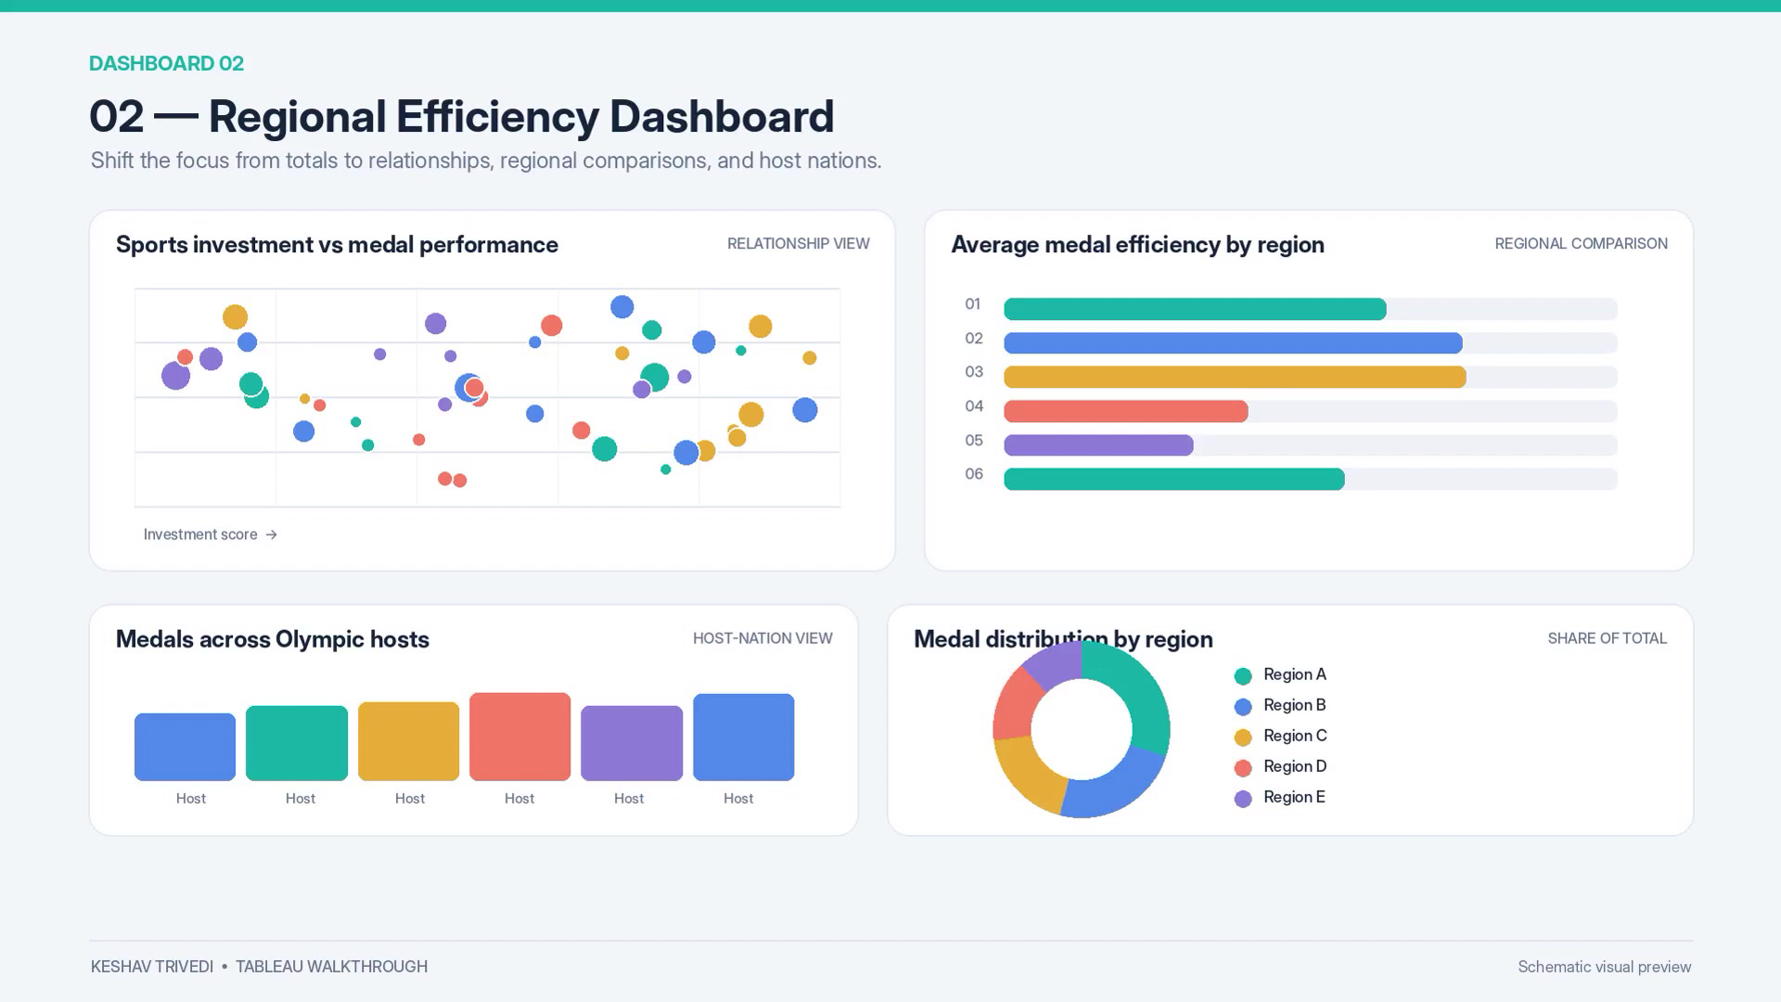
Figure 2. Regional Efficiency Dashboard visual from the project walkthrough.

Tableau Public Publication
Status: not verified/published from the provided files. The workbook is packaged as a .twbx. Open it in Tableau Desktop/Public, review credentials and source-data permissions, publish if appropriate, then replace this line with the real public URL. Do not use an example URL.

